

**Presents Screen on the Green**

***Willy Wonka and the Chocolate Factory***

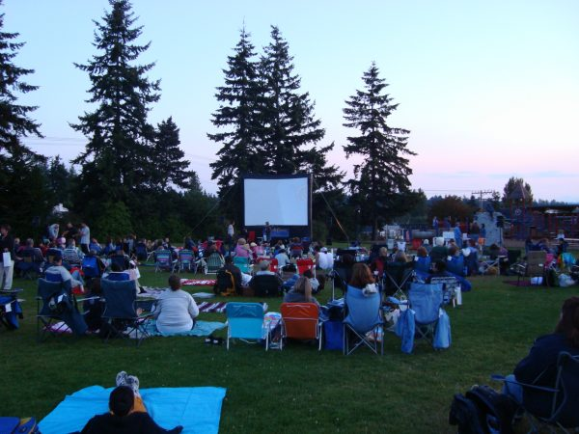

**Where: SSSAS Upper Campus football field**

**Who: All SRCA residents are welcome!**

**When: Thursday, 29 July, starting at 7:30pm. Rain date: Friday, 30 July.**

**Bring your blankets, pillows and cushions (but no chairs) for a fun night of entertainment. Seating is also available on the bleachers.**

**SRCA will provide ice cream and popcorn will be provided courtesy of Bertles Real Estate, McEnearney Associates, both starting at 7:30pm**

**The movie will start at approximately 8:00pm**