Photograph Comparison of Strawberry Run’s
2010 Failed Natural Channel Design (NCD)
(photographs before and upon NCD completion)

Compared with Photographs from Same Vantage Points 2021

Joe Sestak
Joe@Joesestak.com
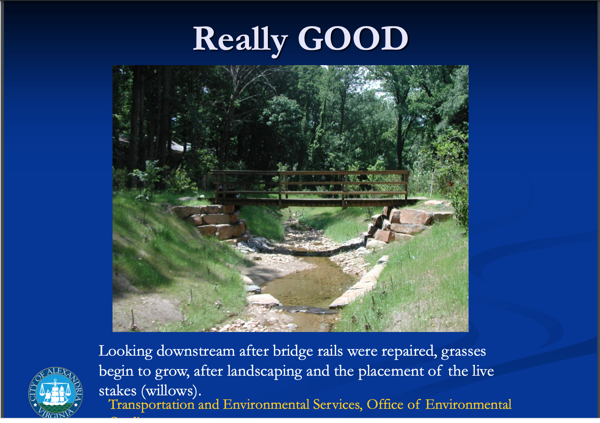 | 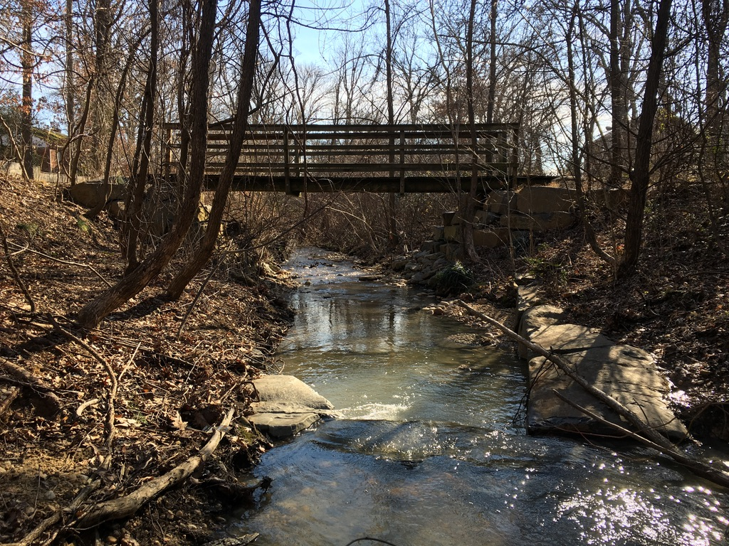
The photographs in the Left Column of this document are taken from the City of Alexandria’s presentation when it completed the Strawberry Run Natural Channel Design (NCD) in 2010. https://www.alexandriava.gov/uploadedFiles/tes/oeq/info/StrawberryRunStreamRestorationWebpage.pdf  The photographs In the Right Column of this documents were taken in 2021 from the same vantage points as the City’s 2010 photographs to show the failure of a Natural Channel Design being done in Strawberry Run.  The photograph above is the City’s looking downstream after the 2010 stream restoration was completed.  In the opposite Right Column are two 2021 photographs taken from same spot as the 2010 photo. They show how the banks eroded away again all along the stream, and that the narrow streambed seen just past the bridge has vastly widened as the banks eroded back again. | 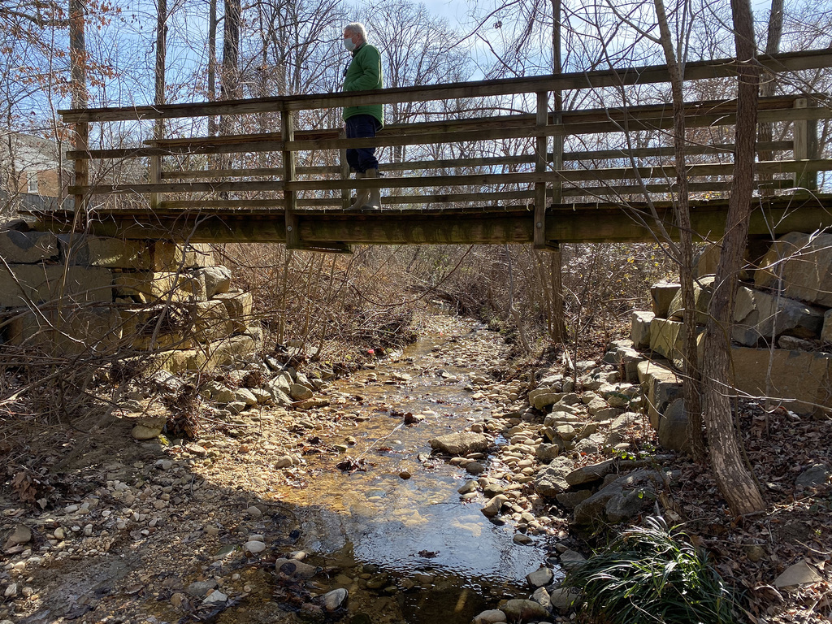
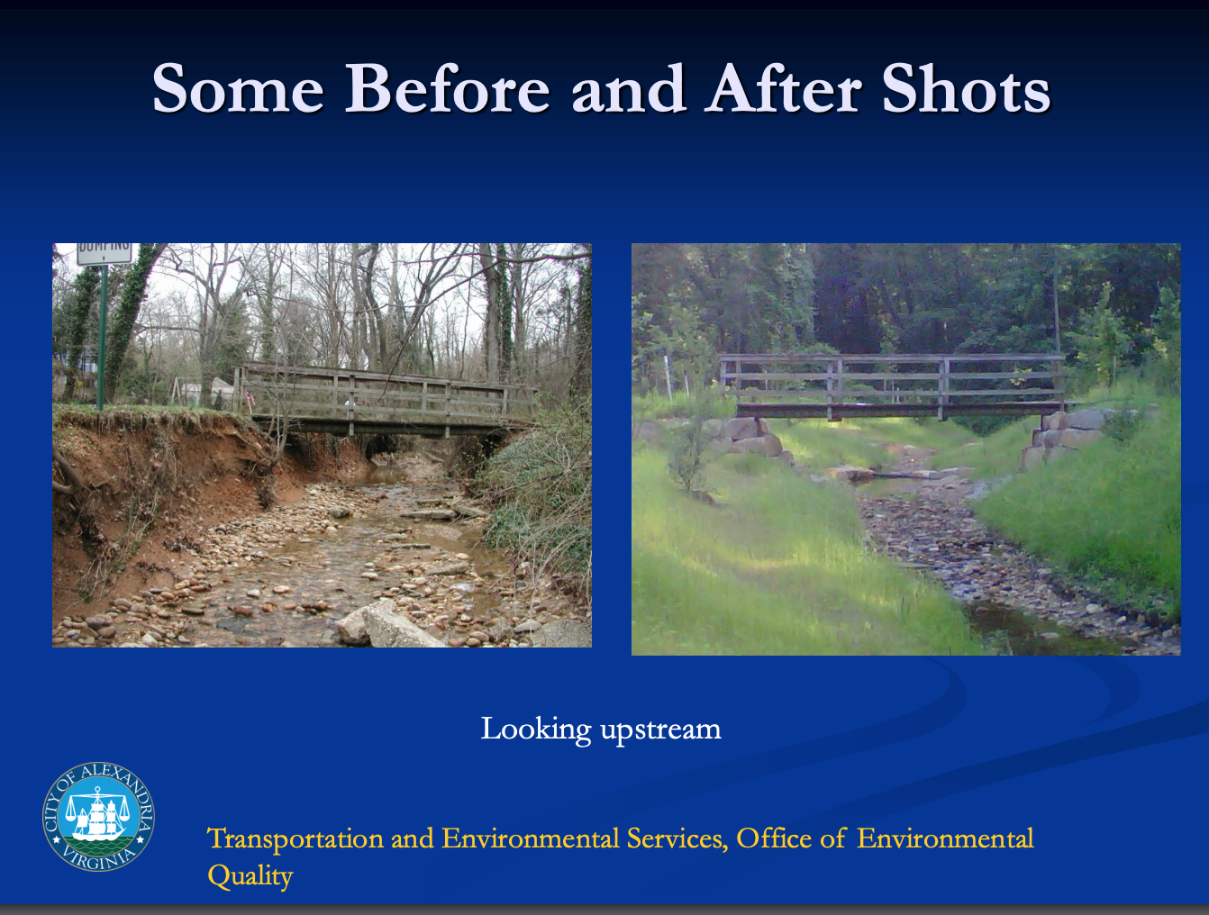 | 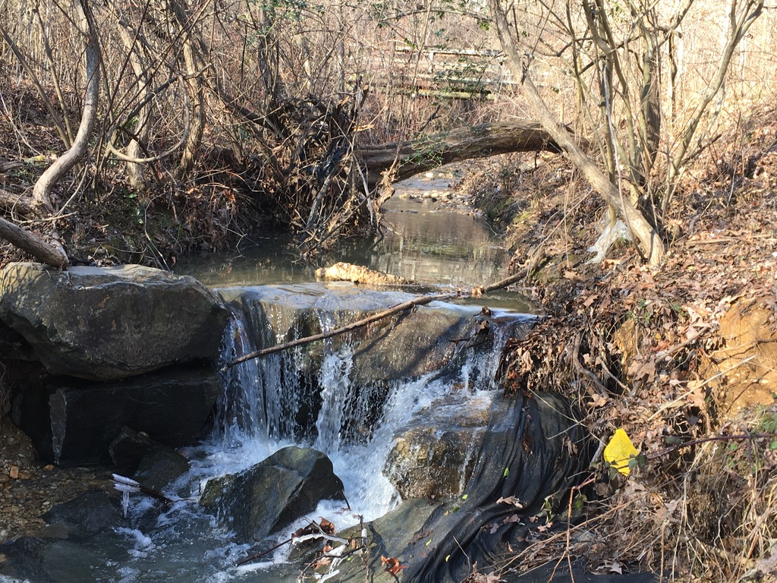
The above photographs are the ~2005 “before” NCD and the 2010 “after” NCD, looking upstream towards the bridge.  The two 2021 photographs on the right show:  (1) The bridge is at the top of both 2021 photos and it is viewed from the same vantage point as the 2010 photo. In the top one, stream banks have again eroded back so much that a large tree’s emplacement that was there in 2010 has eroded away and fallen across the stream.  Photo also shows an “active head cut” that Expert’s Panel says makes use of the BANCS model for stream restoration upstream INEFFECTIVE – but the City is using it for Strawberry Run’s restoration that is adjacent and upstream, with the probability of failing again.  (2) Bottom photo shows sides of 2010 NCD Cross Vane completely blown out with huge boulders carried downstream. Landscape fabric holding emplaced soil/sediment ripped out throughout NCD. | 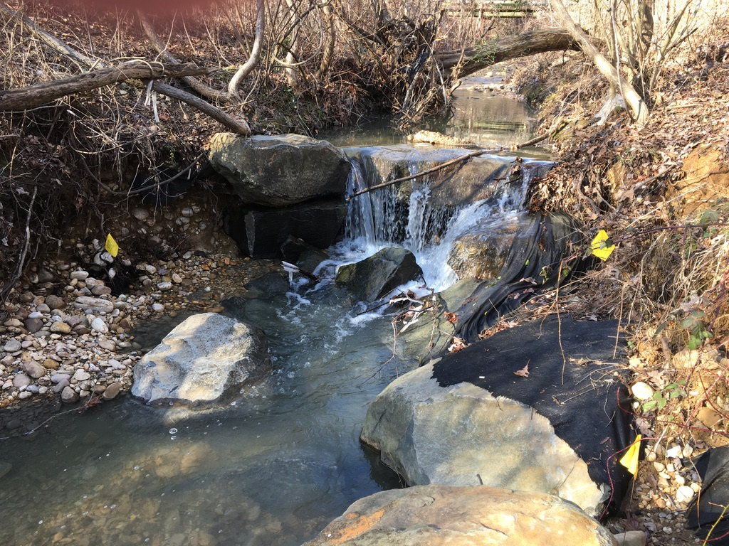
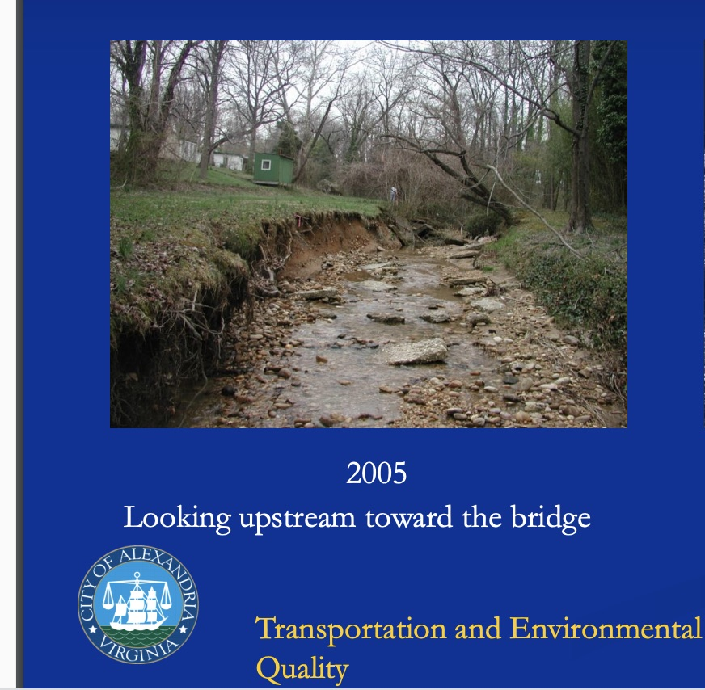 | 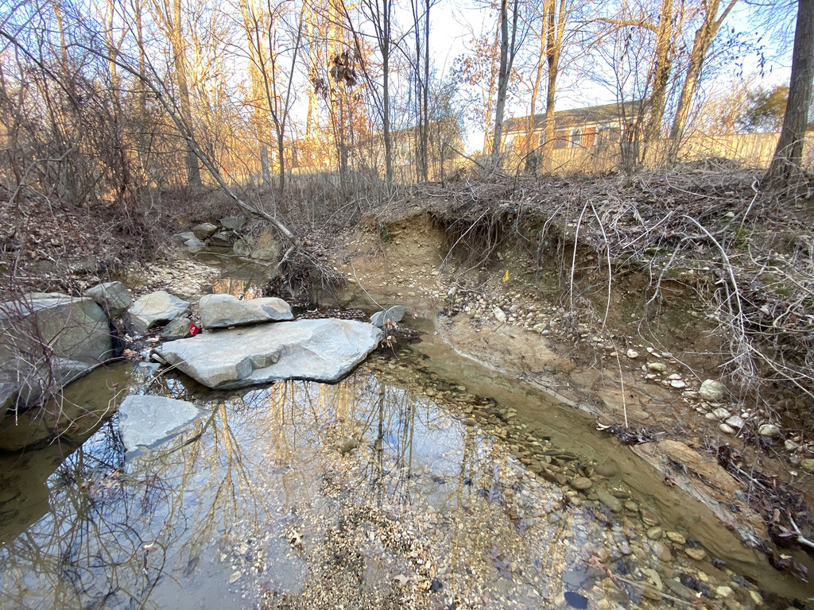
The above 2005 photo is looking upstream prior to the 2010 NCD being done.  The two 2021 photos on the right from near the same vantage point:  (1) Top right photo shows the complete failure of the 2010 NCD as the stream banks have eroded back to their 2005 state, or worse. This Cross Vane has also blown out as all the boulders on the right side have been carried downstream and all but one boulder on the left side. You can see boulders that have washed down from the upstream NCD Cross Vane, one sitting on top of the huge boulder in the middle with others beside it. The landscape fabric has all been ripped away.  (2) The bottom photo on the right shows the complete failure of the right side of the NCD Cross Vane with devastating bank erosion. All of the soil/sediment that was emplaced has been washed away. | 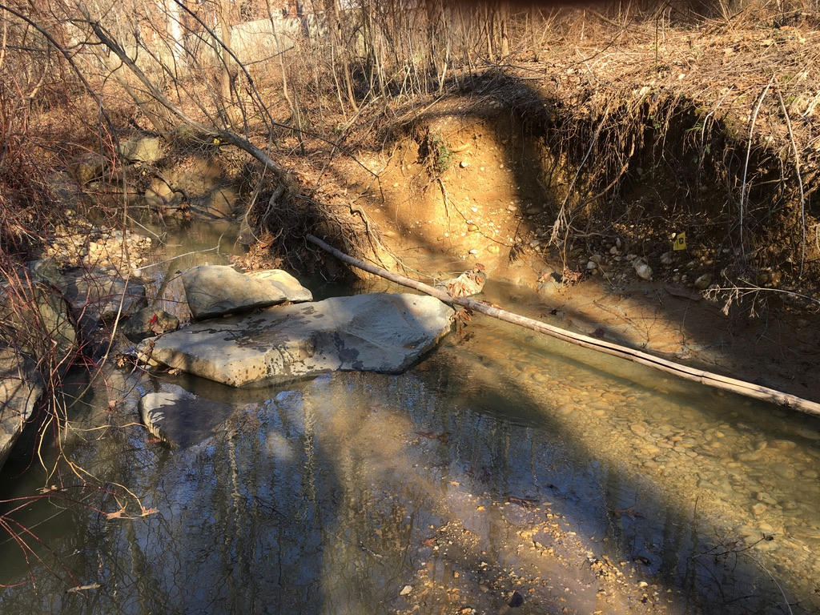
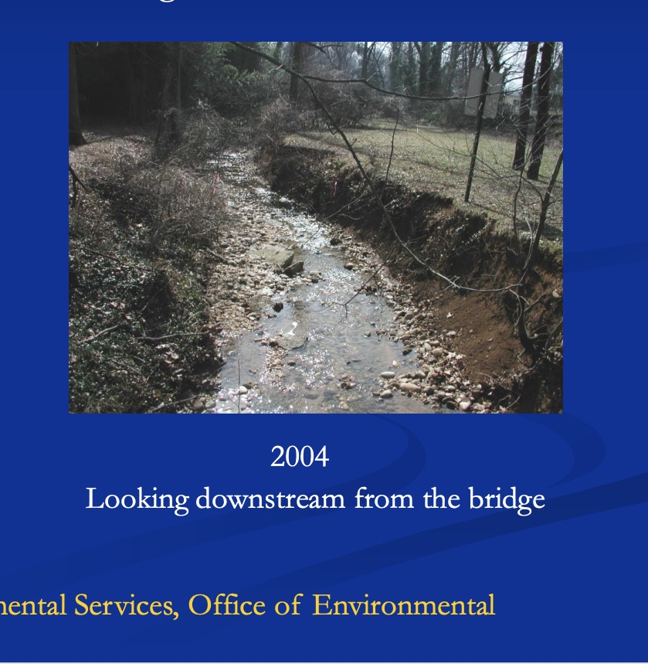 | 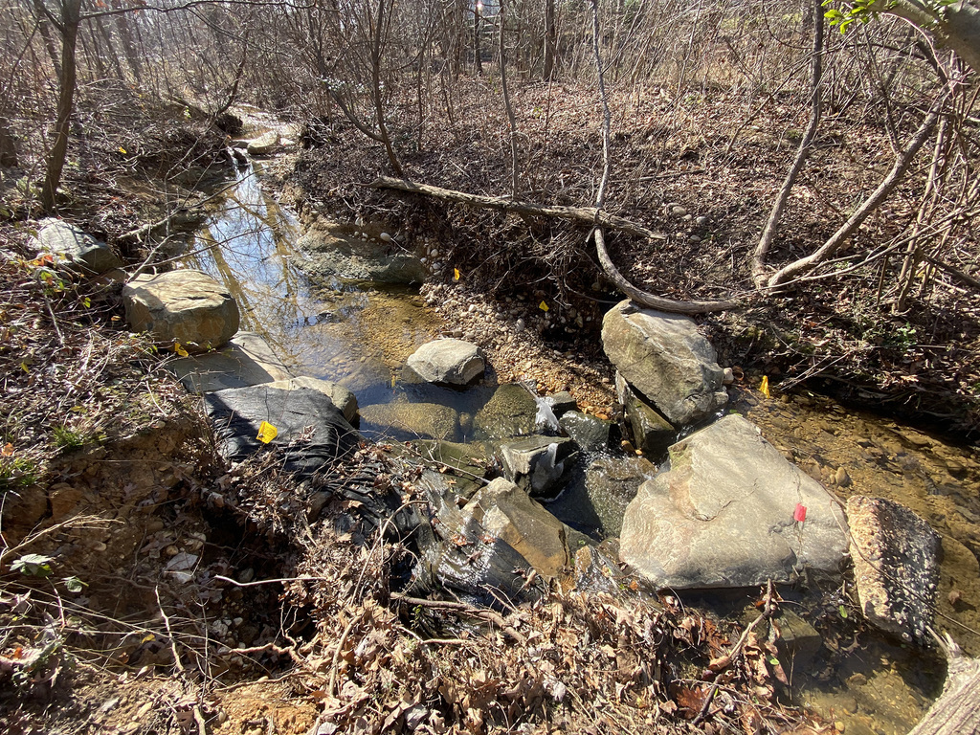
The above 2004 photo is looking upstream prior to the 2010 NCD being done.

The 2021photo on the top right shows the same downstream view with both sides of the 2010 NCD Cross Vane blown out with boulders pulled away from banks, some strewn downstream. The stream banks have eroded back again and all the embedded soil/sediment that was placed in the stream has washed away, with all the covering landscape fabric ripped out.

The photo also shows boulders blown downstream from another destroyed NCD Cross Vane upstream.

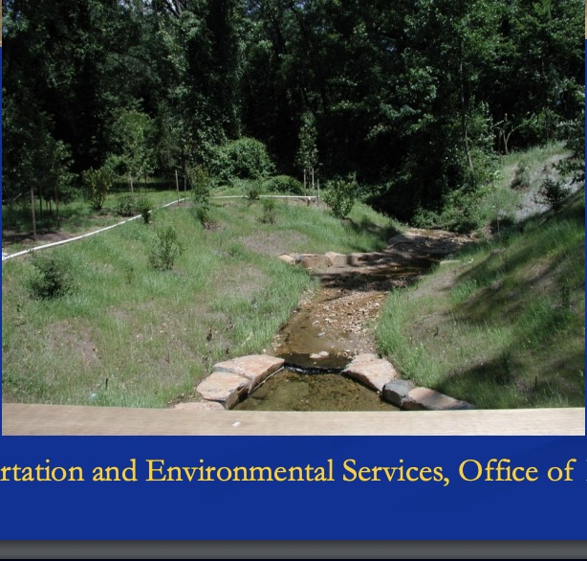 | 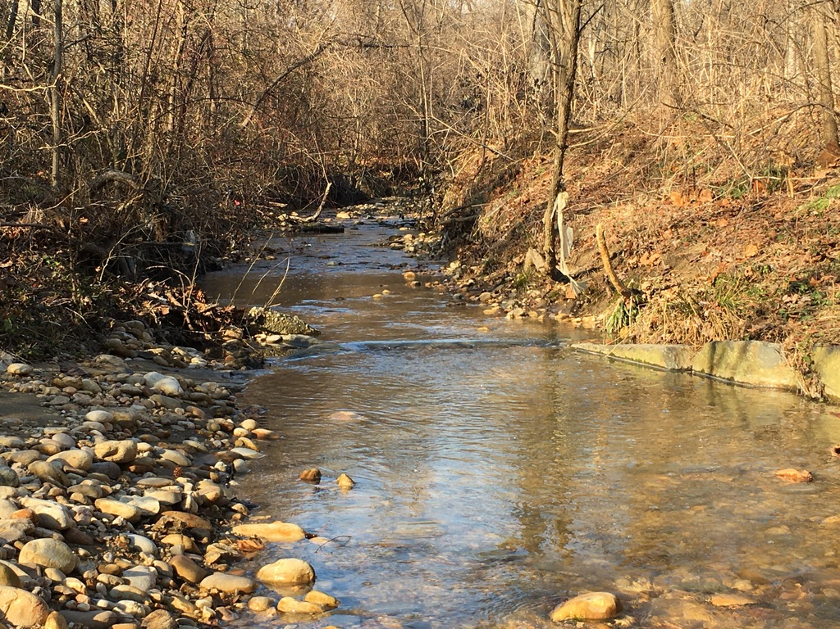
The above post 2010 NCD photo is looking upstream.  On the right, there are two 2021 photos that:  (1) The top photo on right shows the same NCD Cross Vane from the same vantage point looking upstream (center boulder is just visible). The left side of the Cross Vane is blown away, and only the first part of the right side is still there, but is not firmly embedded in the bank.  You can see the severe erosion that has occurred all upstream as the banks have returned to, or are worse than, where they were before the 2010 NCD.  (2) The bottom photo is looking upstream just in front of the Cross Vane. It shows the vast erosion and damage to the NCD design. All the emplaced soil/sediment has been washed away with grave damage. | 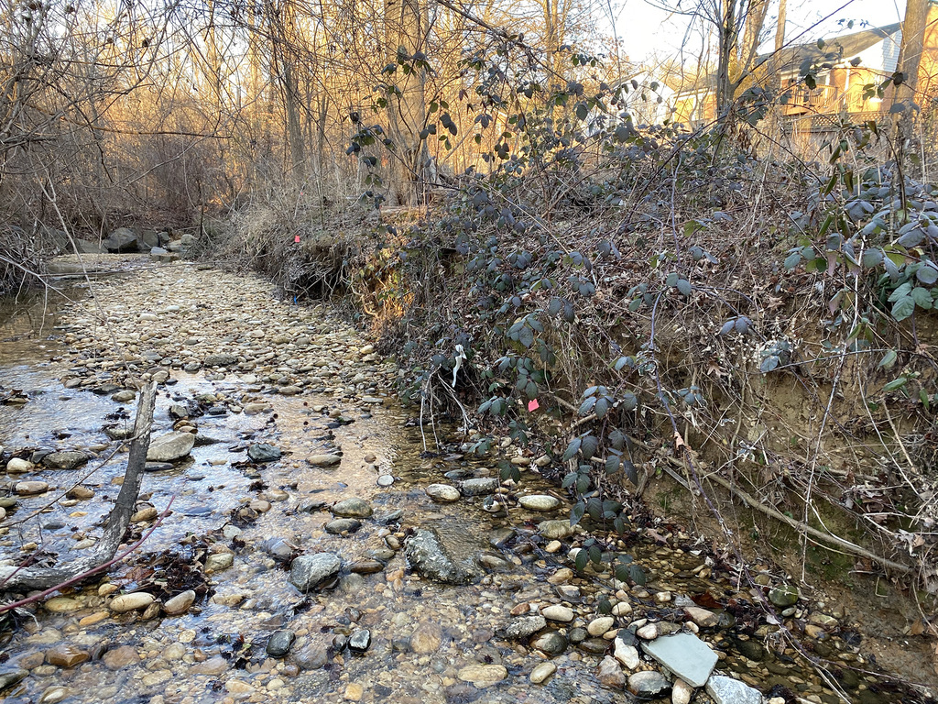
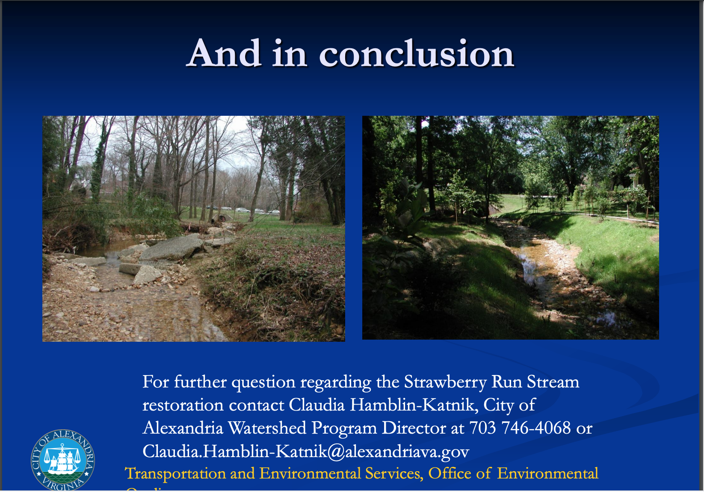 | 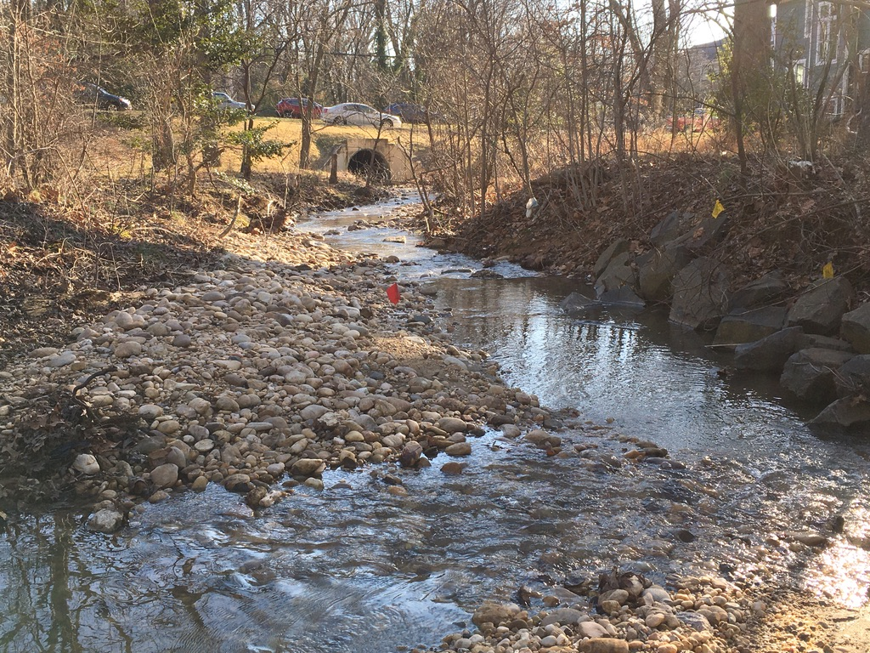
The above photographs are the ~2005 “before” NCD and the 2010 “after” NCD looking downstream to the end of Strawberry Run where it ends at Duke Street and goes into a piped culvert (the large piped culvert is visible underneath the cars driving on Duke Street.  The two 2021 photographs on the right show:  (1) The top one is the same downstream view towards the piped culvert under Duke Street. You can see that the soil/sediment that was emplaced has washed out all along the stream leaving beds of banked sediment in the stream and the remaining soil has run into the Chesapeake Bay.  The stream eroded back and widened greatly as the NCD boulders on the right side of the stream have all been pulled away from the bank.  (2) The bottom photo is the same vantage point as the top left photo of 2010, and a few feet bacl from the top right photo of 2021. The erosion has returned to its 2005 state -- or worse. | 