Seminary Ridge Civic Association
Community Yard Sale
(Enter on Fort Williams Parkway or St. Stephens Road)

Saturday, May 14, 2022
8:00 AM to 12:00 Noon
NO EARLY BIRDS!

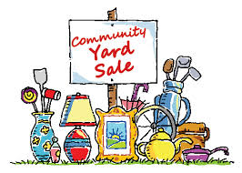

The SRCA Community Yard Sale is being held on Saturday, May 14. What you don’t sell on May 14, you can donate to charity as the City no longer is providing a trash pick-up day by zone.

Please notify your neighbors of this “once-a-year” SRCA Community Yard Sale. Signage will be placed by SRCA at entrance points (Fort Williams Parkway and St. Stephens Road) to the community. Maps of participating homes will be available at each sale site.

To register/participate contact Kate Hennigan (SRCA Vice President for Events) at: kate@bertlesrealestate.com or 202-321-3427.

