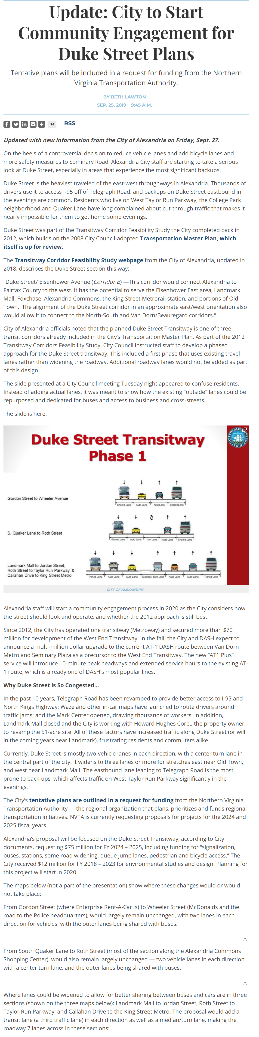
Source: Alexandria Living Magazine

